**Gorkha Nepal earthquake amplification and frequency characteristics**

**Alex Vanderhoeff**

**April 10, 2019**

**Introduction**

The aim of this project is to try and quantify the amplification of shaking during the 2015 Gorkha, Nepal earthquake at 2 soil sites located near Kathmandu. This earthquake occurred on April 25, 2015 and was a 7.8 magnitude (Mw) earthquake along the main Himalayan thrust fault. Its epicentre was near Gorkha, about 80Km away from Kathmandu, Nepal. Kathmandu is surrounded by mountains and sits on soft lake sediments more than 650 metres (m) deep (Takei et al, 2016). Soft sediments have the effect of amplifying shaking during earthquakes, resulting in larger intensities locally around the soft sediments. Because of this, sites sitting on soft sediments can experience significantly more damage than sites on bedrock or harder sediments. It is estimated that 12% of buildings in the Kathmandu valley were reported as completely damaged (Bijukchhen et al, 2017), and this could be attributed to the amplification of seismic waves by the soft sediments of the Kathmandu valley.

The amplification effects of soft soils can be quantified by computed standard spectral ratios (SSR) which is found by dividing the Fourier transform of the acceleration time series for the soft sediment site in question by a bedrock reference site that ideally has no amplification. This has been done in (Takei et al, 2016). In this report, the amplification will be determined by calculating the horizontal – vertical spectral ratio (HVSR), which provides a lower limit on the amplification at a site. The benefit of this method is that a reference site is not needed to compute it, allowing it to be computed independently at each site. It is calculated by taking the smoothed Fourier transforms of the acceleration time series components then using: $\begin{aligned}HVSR=\frac{\sqrt{\left(E-Wcomponent\right)\left(N-Scomponent\right)}}{Vertical component}\#\left(1\right)\end{aligned}$

This formula is found in (Lermo & Chavez – Garcia, 1993) and was first determined to be a viable method to estimate of shaking amplification during an earthquake in that same study in 1993. After the amplification is computed, the acceleration time series of the earthquake will then be analyzed by plotting the power spectral density (PSD), the cross -power spectral density (CPSD) and spectrogram plots. This will tell us which frequencies provided the most energy in the earthquake and will show the correlation between the vertical, E-W and N-S components for the acceleration time series between the sites used.

The data used is acceleration – time data and was collected from 2 strong motion accelerometers located in the Kathmandu valley, both sitting on soft sediment sites (Takei et al, 2016). One station is in the central department of geology at Tribhuvan university (TVU) and the other is in the university grants office in Sanothimi, Bhaktapur (THM). These sites are shown in figure 1 as the yellow markers (TVU the left yellow marker, THM the right yellow marker) in relation to the earthquake epicentre (red marker). The data set was obtained from Dr. Molnar of the earth sciences department.

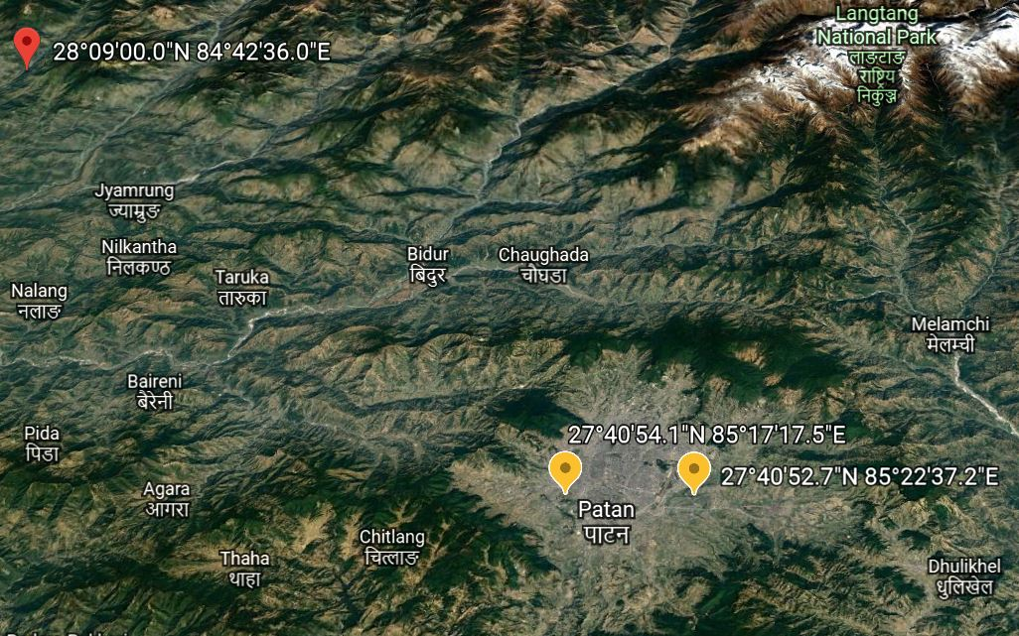

Figure 1: Map of Nepal showing the location of the seismic recording station (yellow) and the earthquake epicentre (red)

**Data analysis**

The data analyzed was acceleration - time series data taken by 2 accelerometers located in the Kathmandu valley. The data had a sampling frequency of 100 Hz and was collected for about 100 seconds. The data quality is very high and there is no major outliers or discrepancies found. The data recorded is not only earthquake ground acceleration data. The data then needed to be processed. First, the data was detrended and the mean was removed from the data to remove distortions from the data that a trend may cause. There is also noise in the data that lies outside the frequency of the data collected. Because of this, a bandpass filter was used to filter out the wanted signal (0.05 – 20 Hz frequency) from the unwanted frequencies that are not characteristic of earthquakes. This was then applied to the Vertical, N-S, and E-W components of the acceleration time series and then plotted (figure 2 and figure 3). The max displacement, peak ground acceleration (PGA) and peak ground velocity (PGV) were then found. To do this, the time series was integrated once for the velocity time series, then again to get the displacement time series, the displacement time series for THM and TVU were then plotted in figures 4 and 5 respectively. The velocity time series for THM and TVU were also plotted in figures 6 and 7 respectively. These figures are displayed in results. Following this, the time series were then transformed into the frequency domain using the Fourier transform. The Fourier transforms then needed to be smoothed, so a running mean average filter was used to smooth the transforms. The unsmoothed and smoothed transforms are plotted for TVU and THM in figure 8 and figure 9 respectively. Once this was all done, the CPSD (figure 10) and PSD (figure 11 for THM, figure 12 for TVU), spectrograms (figure 13 for THM, figure 14 for TVU) and HV spectral ratios (figure 15) could then be calculated and plotted.

**Results**

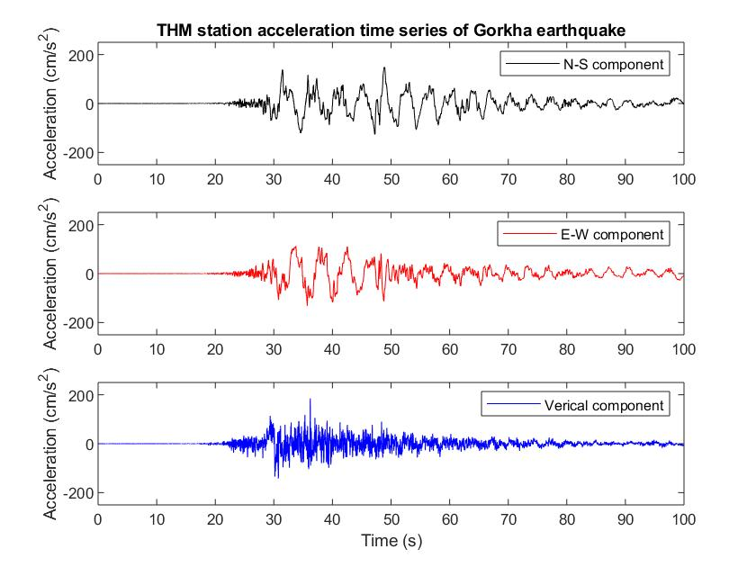

Figure 2: Acceleration time series for THM station.

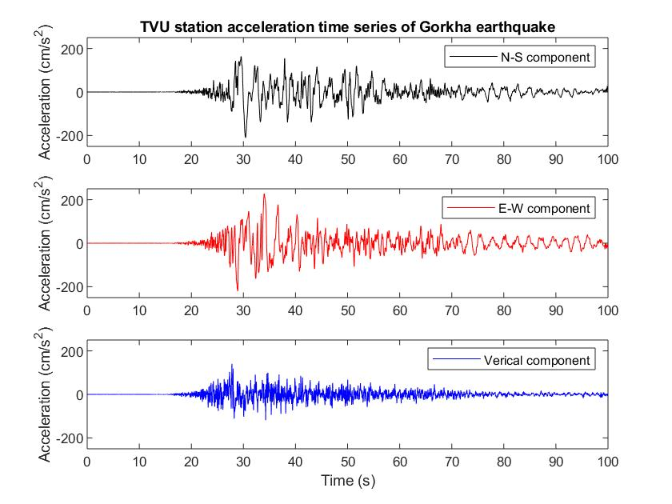

Figure 3: Acceleration time series for station TVU.

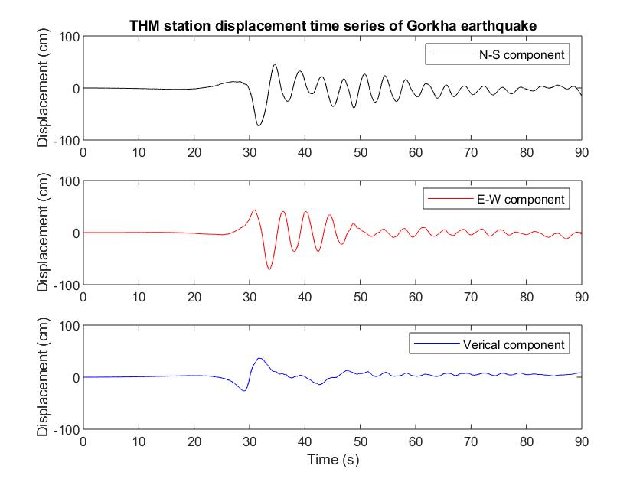

Figure 4: Displacement time series for station THM.

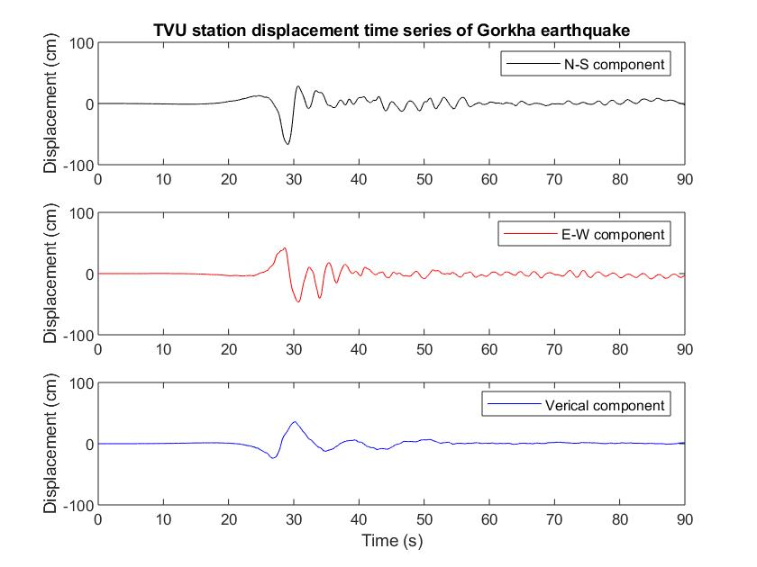

Figure 5: Displacement time series for station TVU.

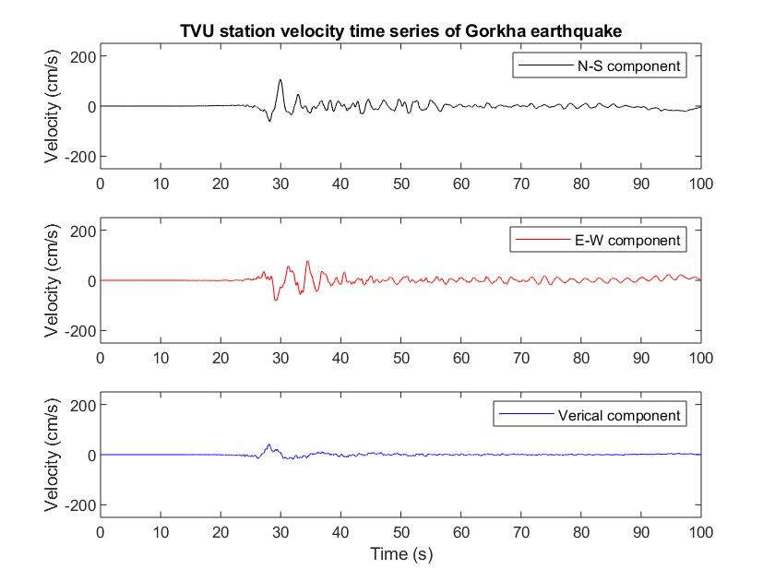

Figure 6: Velocity time series for station TVU.

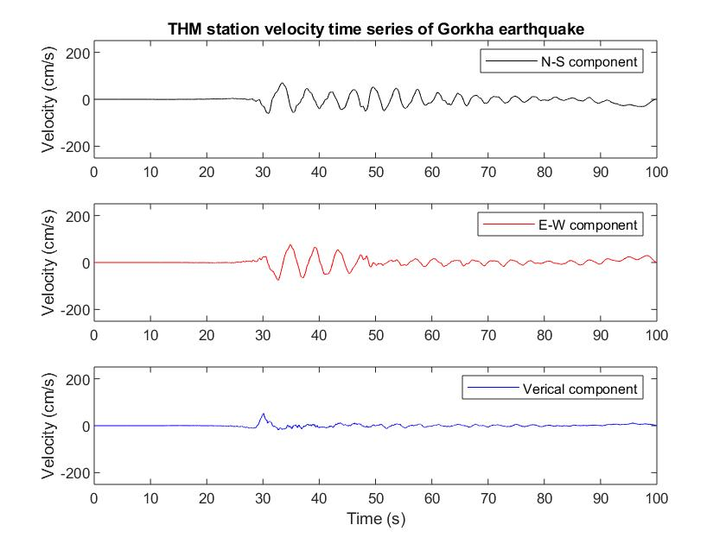

Figure 7: Velocity time series for station THM.

Table 1: PGA, PGV and max displacement for the N-S, E-W and vertical components at station TVU.

|  |  |  |  |
| --- | --- | --- | --- |
| **Component** | **PGA (cm/s2)** | **PGV (cm/s)** | **Max displacement** |
| N-S | 210 | 106 | 134 |
| E-W | 223 | 81 | 91 |
| Vertical | 140 | 41 | 35 |

Table 2: PGA, PGV and max displacement for the N-S, E-W and vertical components at station THM.

|  |  |  |  |
| --- | --- | --- | --- |
| **Component** | **PGA (cm/s2)** | **PGV (cm/s)** | **Max displacement** |
| N-S | 150 | 70 | 202 |
| E-W | 132 | 77 | 141 |
| Vertical | 185 | 53 | 63 |

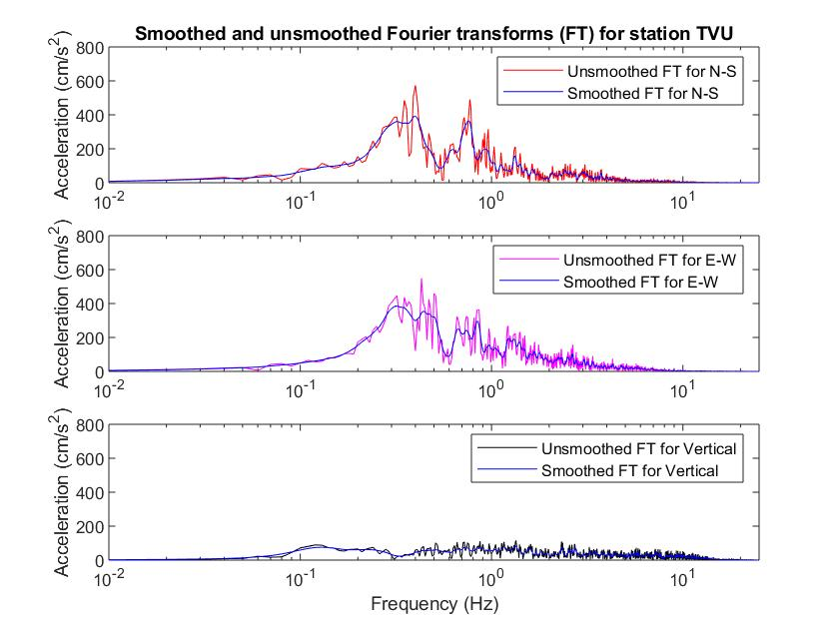

Figure 8: Smoothed and unsmoothed FT for station TVU.

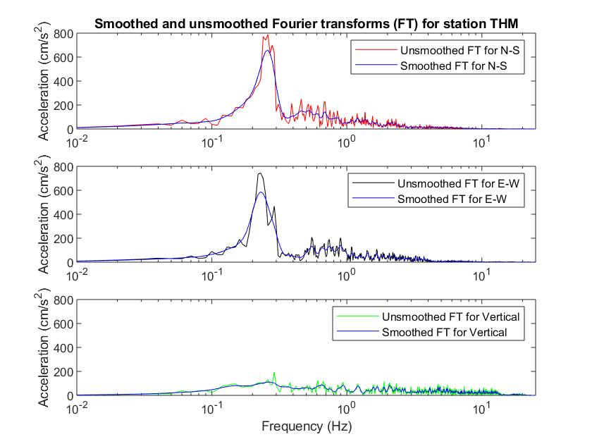

Figure 9: Smoothed and unsmoothed FT for station THM.

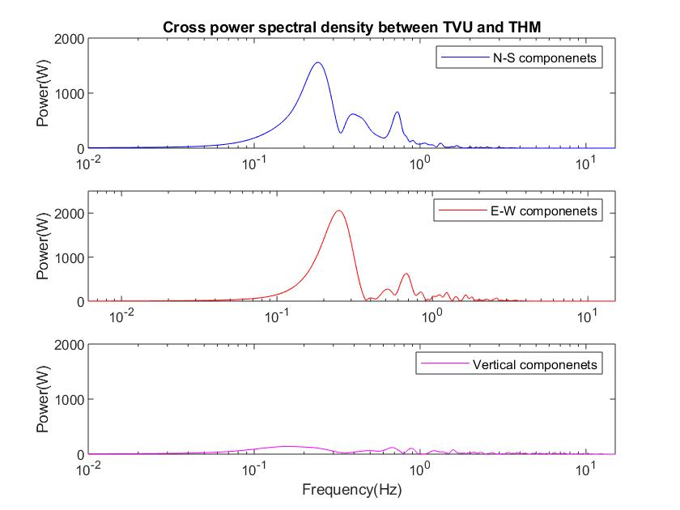

Figure 10: CSPD between stations TVU and THM.

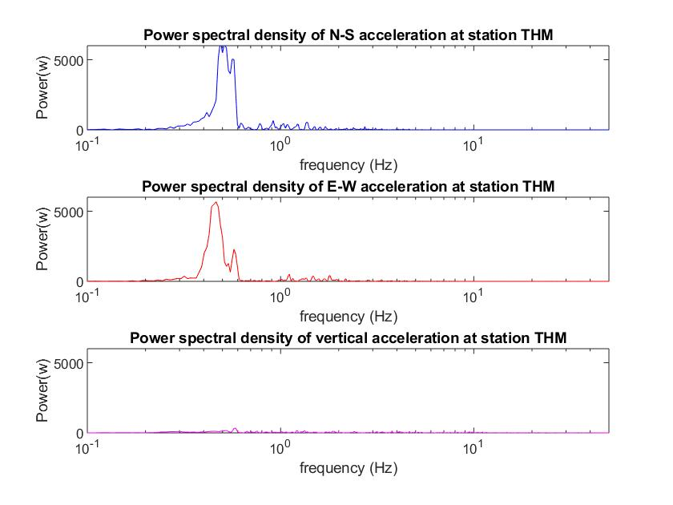

Figure 11: PSD for station THM.

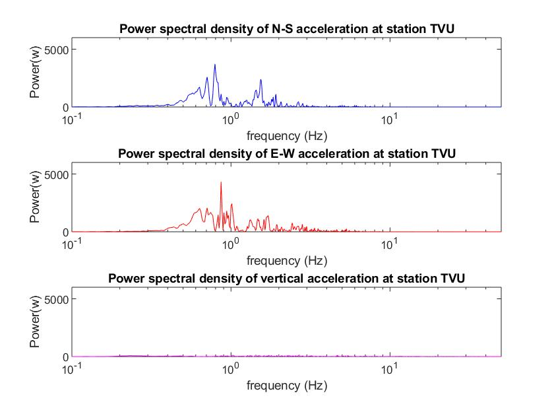

Figure 12: PSD for station TVU.

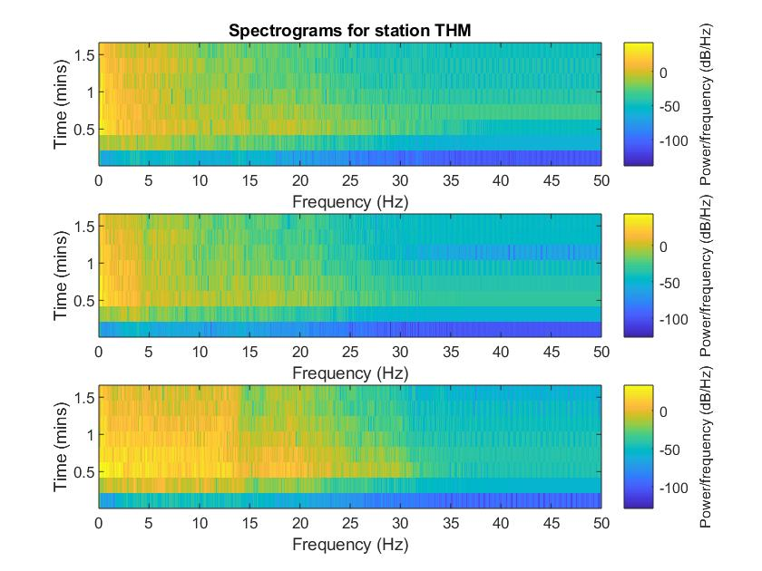

Figure 13: Spectrograms for station THM of the N-S (top), E-W (middle), and vertical (bottom) components.

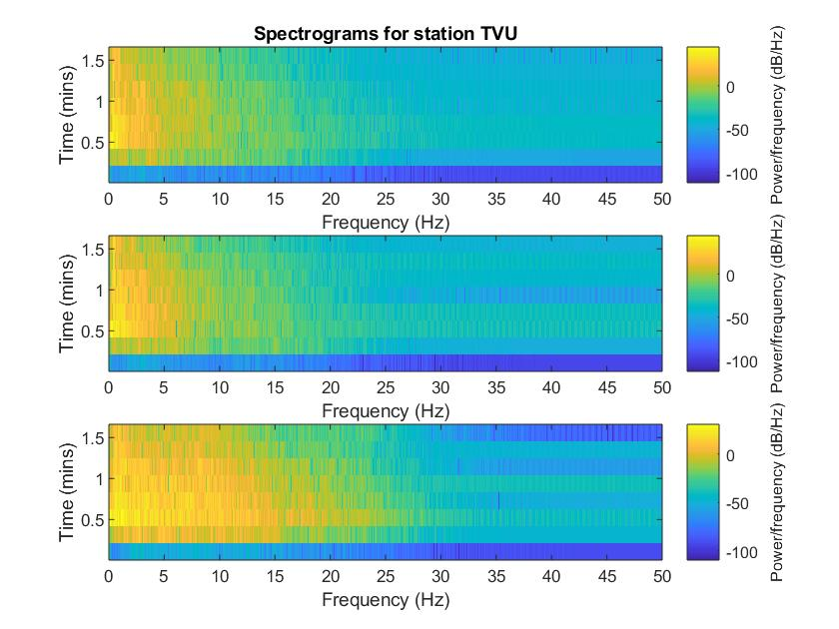

Figure 14: Spectrograms for station TVU for N-S (top), E-W (middle), and vertical (bottom) components.

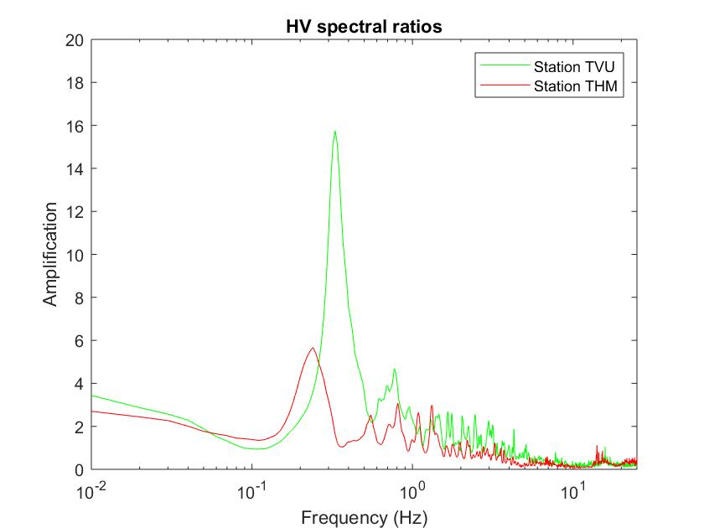

Figure 15: HVSR for station TVU and THM.

**Discussion**

The plots of the time series of the data show that the seismic waves generated by the earthquake arrived at station TVU slightly earlier than station THM. They also show that the PGA at station TVU was larger for all 3 components of acceleration than THM, but that the peak displacement and peak velocities were mostly all larger at station THM than station TVU. With regards to amplification, the larger PGA at TVU makes sense, since the amplification is shown to be larger at TVU than THM in figure 15, with the amplification at TVU being a factor of about 16 while the amplification at THM is about a factor of 6. Since amplification is a measure of how much the acceleration is amplified at each frequency, it makes sense that a larger amplification corresponds to a larger PGA. The larger PGV and max displacement at THM could be explained due to topographic effects of shaking or something else, but the reason for the larger PGV and displacements is unknown.

The CPSD plot between station TVU and THM for each component shows that there is a strong correlation of the power between frequencies 0.1-0.6Hz for both N-S and E-W directions. The vertical direction does not provide much power and as such does not have as large of a correlation between the two stations vertical direction time series as the other directions have.

The PSD plots for stations TVU and THM show that most of the power of the seismic waves is coming from frequencies about 0.4-1 Hz. TVU shows that frequencies about 0.8Hz are providing most of the energy at the station while for THM, frequencies of about 0.5Hz are providing most of the energy. The PSD plots also show that the vertical acceleration of seismic waves isn’t providing as much energy. This makes sense as P – waves have a motion in the vertical direction and they are lower energy and amplitude than S - waves and surface waves. The PSD’s can be related to amplification also because the HVSR plot shows that the frequencies being amplified most are slightly different for the 2 sites, with THM having a lower frequency of about 0.2-0.4Hz amplified more while the HVSR for TVU shows that frequencies of about 0.4 - 0.8Hz are being amplified the most at the site.

The spectrograms for the THM and TVU sites for each direction show that after about 30 seconds, most of the energy arrives, the, and the energy is similar until about 60 seconds, where after it starts to decrease. They both also show that the vertical section has the largest amount of energy at higher frequencies from about 5Hz to 20Hz. They also show that the lowest frequencies around 0.2-1Hz is the frequency where most of the energy of the seismic waves is. The spectrograms also show that the frequency where most of the energy of the seismic waves is located is not changing much with time but is relatively stationary at the same values.

**Conclusion**

In this report, the HVSR was calculated and compared to SSR from (Takei et al, 2016). It was found to be close to the SSR and shows that HVSR provides a good lower limit on the amplification at a site. It was also found that the PGA was greater at site TVU than THM, which is in agreement with HVSRs that show it has a larger amplification and thus softer soils than THM. It was also found that the dominant frequency that supplied the most energy was between 0.1 – 1Hz. This was shown from the spectrogram and PSD plots. Future research in this area could include other types of data such as refraction and reflection data and perhaps invasive data, which could give an idea of what the soils beneath the site are. This would allow Vs30 to be determined and would be better able to classify shaking and the hazard at the site.

**References**

Takai et al. (2016). Strong ground motion in the Kathmandu Valley during the 205 Gorkha, Nepal, earthquake. Earth, Planets and Space 68, doi 10.1186/s40623-016-0383-7

[2] Bijukchhen et al. (2017). Strong-motion characteristics and visual damage assessment around seismic stations in Kathmandu after the 2015 Gorkha, Nepal, earthquake. Earthquake Spectra, 22, S219-S242, doi 10.1193/042916EQS074M

[3] Lermo, J. Chavez – Garcia, F. J. (1993). Site effect evaluation using spectral ratios with only one station. Bulletin of the seismological society of America. Vol. 83, 5, 1574-1594.

**Appendices (for code)**

%% Project code

%Processing earthquake data to show characteristics and amplification of

%the earthquake in two sites in Nepal

%Alex vanderhoeff

%250858436

%%

%reading data

close all

fileID1=fopen('TVU001504250611.dat');

fileID2=fopen('THM001504250611.dat');

formatSpec='%f%f%f%f';

TVUdata=textscan(fileID1,formatSpec,'HeaderLines',34);

THMdata=textscan(fileID2,formatSpec,'HeaderLines',34);

fclose(fileID1);

fclose(fileID2);

t1=TVUdata{1,1};

t4=THMdata{1,1};

time_THM=THMdata{1,1};

time_TVU=TVUdata{1,1};

%%

%detrending and removing mean from data

%TVU

TVU2 = detrend(TVUdata{1,2}); %remove linear trend

TVU22 = TVU2 - mean(TVUdata{1,2}); %remove mean offset

TVU3 = detrend(TVUdata{1,3}); %remove linear trend

TVU33 = TVU3 - mean(TVUdata{1,3}); %remove mean offset

TVU4 = detrend(TVUdata{1,4}); %remove linear trend

TVU44 = TVU4 - mean(TVUdata{1,4}); %remove mean offset

% %THM

THM2 = detrend(THMdata{1,2}); %remove linear trend

THM22 = THM2 - mean(THMdata{1,2}); %remove mean offset

THM3 = detrend(THMdata{1,3}); %remove linear trend

THM33 = THM3 - mean(THMdata{1,3}); %remove mean offset

THM4 = detrend(THMdata{1,4}); %remove linear trend

THM44 = THM4 - mean(THMdata{1,4}); %remove mean offset

%%

%create the filter

fs = 100 ; % sampling frequency

dt = 1/fs;

order = 2; % order of the filter

low_cut = 0.05; % low-cut cutoff frequency

high_cut = 20; %high-cut cutoff freq

[b1,a1]=butter(2,[low_cut high_cut]/(fs/2),'bandpass'); %bandpass filter for both stations

%%

%apply the butter filter

%THM

THM22_filt_accel=filtfilt(b1,a1,THM22);

THM33_filt_accel=filtfilt(b1,a1,THM33);

THM44_filt_accel=filtfilt(b1,a1,THM44);

%TVU

TVU22_filt_accel=filtfilt(b1,a1,TVU22);

TVU33_filt_accel=filtfilt(b1,a1,TVU33);

TVU44_filt_accel=filtfilt(b1,a1,TVU44);

%%

%compute velocities

v2_THM = cumsum(THM22_filt_accel)*dt;% (cm/s)

v3_THM = cumsum(THM33_filt_accel)*dt;% (cm/s)

v4_THM = cumsum(THM44_filt_accel)*dt;% (cm/s)

v2_TVU = cumsum(TVU22_filt_accel)*dt;% (cm/s)

v3_TVU = cumsum(TVU33_filt_accel)*dt;% (cm/s)

v4_TVU = cumsum(TVU44_filt_accel)*dt;% (cm/s)

%%

%compute displacement

d2_THM = cumsum(v2_THM)*dt;%(cm)

d3_THM = cumsum(v3_THM)*dt;%(cm)

d4_THM = cumsum(v4_THM)*dt;%(cm)

d2_TVU = cumsum(v2_TVU)*dt;%(cm)

d3_TVU = cumsum(v3_TVU)*dt;%(cm)

d4_TVU = cumsum(v4_TVU)*dt;%(cm)

%% Plots

%Acceleration

%THM22

figure(1)

subplot(3,1,1)

plot(time_THM,THM22_filt_accel,'k');

ylabel('Acceleration (cm/s^2)');

legend('N-S component');

axis([0 100 -250 250]);

title('THM station acceleration time series of Gorkha earthquake');

subplot(3,1,2)

plot(time_THM,THM33_filt_accel,'r');

ylabel('Acceleration (cm/s^2)');

legend('E-W component');

axis([0 100 -250 250]);

subplot(3,1,3)

plot(time_THM,THM44_filt_accel,'b');

ylabel('Acceleration (cm/s^2)');

legend('Verical component');

axis([0 100 -250 250]);

xlabel('Time (s)');

%TVU

figure(2)

subplot(3,1,1)

plot(time_TVU,TVU22_filt_accel,'k');

ylabel('Acceleration (cm/s^2)');

legend('N-S component');

axis([0 100 -250 250]);

title('TVU station acceleration time series of Gorkha earthquake');

subplot(3,1,2)

plot(time_TVU,TVU33_filt_accel,'r');

ylabel('Acceleration (cm/s^2)');

legend('E-W component');

axis([0 100 -250 250]);

subplot(3,1,3)

plot(time_TVU,TVU44_filt_accel,'b');

ylabel('Acceleration (cm/s^2)');

legend('Verical component');

axis([0 100 -250 250]);

xlabel('Time (s)');

%% Velocity

%THM22

figure(3)

subplot(3,1,1)

plot(time_THM,v2_THM,'k');

ylabel('Velocity (cm/s)');

legend('N-S component');

axis([0 100 -250 250]);

title('THM station velocity time series of Gorkha earthquake');

subplot(3,1,2)

plot(time_THM,v3_THM,'r');

ylabel('Velocity (cm/s)');

legend('E-W component');

axis([0 100 -250 250]);

subplot(3,1,3)

plot(time_THM,v4_THM,'b');

ylabel('Velocity (cm/s)');

legend('Verical component');

axis([0 100 -250 250]);

xlabel('Time (s)');

%TVU

figure(4)

subplot(3,1,1)

plot(time_TVU,v2_TVU,'k');

ylabel('Velocity (cm/s)');

legend('N-S component');

axis([0 100 -250 250]);

title('TVU station velocity time series of Gorkha earthquake');

subplot(3,1,2)

plot(time_TVU,v3_TVU,'r');

ylabel('Velocity (cm/s)');

legend('E-W component');

axis([0 100 -250 250]);

subplot(3,1,3)

plot(time_TVU,v4_TVU,'b');

ylabel('Velocity (cm/s)');

legend('Verical component');

axis([0 100 -250 250]);

xlabel('Time (s)');

%% Displacement

%THM22

figure(5)

subplot(3,1,1)

plot(time_THM,d2_THM,'k');

ylabel('Displacement (cm)');

legend('N-S component');

axis([0 90 -100 100]);

title('THM station displacement time series of Gorkha earthquake');

subplot(3,1,2)

plot(time_THM,d3_THM,'r');

ylabel('Displacement (cm)');

legend('E-W component');

axis([0 90 -100 100]);

subplot(3,1,3)

plot(time_THM,d4_THM,'b');

ylabel('Displacement (cm)');

legend('Verical component');

axis([0 90 -100 100]);

xlabel('Time (s)');

%TVU

figure(6)

subplot(3,1,1)

plot(time_TVU,d2_TVU,'k');

title('TVU station displacement time series of Gorkha earthquake');

ylabel('Displacement (cm)');

legend('N-S component');

axis([0 90 -100 100]);

subplot(3,1,2)

plot(time_TVU,d3_TVU,'r');

ylabel('Displacement (cm)');

legend('E-W component');

axis([0 90 -100 100]);

subplot(3,1,3)

plot(time_TVU,d4_TVU,'b');

ylabel('Displacement (cm)');

legend('Verical component');

axis([0 90 -100 100]);

xlabel('Time (s)');

%% Compute PGA, PGV, max displacement

THM22vel_max=max(abs(v2_THM));

THM33vel_max=max(abs(v3_THM));

THM44vel_max=max(abs(v4_THM));

THM22_filt_accel_max=max(abs(THM22_filt_accel)) ;

THM33_filt_accel_max=max(abs(THM33_filt_accel)) ;

THM44_filt_accel_max=max(abs(THM44_filt_accel));

THM22_d_max=max(abs(d2_THM));

THM33_d_max=max(abs(d3_THM));

THM44_d_max=max(abs(d4_THM));

TVU22vel_max=max(abs(v2_TVU));

TVU33vel_max=max(abs(v3_TVU));

TVU44vel_max=max(abs(v4_TVU));

TVU22accel_max=max(abs(TVU22_filt_accel));

TVU33accel_max=max(abs(TVU33_filt_accel));

TVU44accel_max=max(abs(TVU44_filt_accel));

TVU22_d_max=max(abs(d2_TVU));

TVU33_d_max=max(abs(d3_TVU));

TVU44_d_max=max(abs(d4_TVU));

%% CPSD

figure(7)

subplot(3,1,1);

nfft_1=2^nextpow2(length(TVU22_filt_accel));

[cpsd_Spectra_22,f_spectra_22] = cpsd(TVU22_filt_accel,THM22_filt_accel,[ ],0,nfft_1,fs);

m1=abs(cpsd_Spectra_22);

semilogx(f_spectra_22,m1,'b');

title('Cross power spectral density between TVU and THM');

legend('N-S componenets');

ylabel('Power(W)');

axis([10^(-2) 15 0 2000]);

subplot(3,1,2);

nfft_2=2^nextpow2(length(TVU33_filt_accel));

[cpsd_Spectra_33,f_spectra_33] = cpsd(TVU33_filt_accel,THM33_filt_accel,[ ],0,nfft_2,fs);

m2=abs(cpsd_Spectra_33);

semilogx(f_spectra_33,m2,'r');

legend('E-W componenets');

ylabel('Power(W)');

axis([0 15 0 2500]);

subplot(3,1,3);

nfft_3=2^nextpow2(length(TVU44_filt_accel));

[cpsd_Spectra_44,f_spectra_44] = cpsd(TVU44_filt_accel,THM44_filt_accel,[ ],0,nfft_3,fs);

m3=abs(cpsd_Spectra_44);

semilogx(f_spectra_44,m3,'m');

legend('Vertical componenets');

xlabel('Frequency(Hz)');

ylabel('Power(W)');

axis([10^(-2) 15 0 2000]);

%% PSD

%TVU

figure(8)

subplot(3,1,1)

nfft1=2^nextpow2(length(TVU22_filt_accel));

[p_TVU22,f_TVU22]=periodogram(TVU22_filt_accel,[],nfft1,200);

PSD_TVU22=abs(p_TVU22);

semilogx(f_TVU22,PSD_TVU22,'b');

axis([10^(-1) 50 0 6000]);

title('Power spectral density of N-S acceleration at station TVU');

xlabel('frequency (Hz)');

ylabel('Power(w)');

subplot(3,1,2)

nfft2=2^nextpow2(length(TVU33_filt_accel));

[p_TVU33,f_TVU33]=periodogram(TVU33_filt_accel,[],nfft2,200);

PSD_TVU33=abs(p_TVU33);

semilogx(f_TVU33,PSD_TVU33,'r');

axis([10^(-1) 50 0 6000]);

title('Power spectral density of E-W acceleration at station TVU');

xlabel('frequency (Hz)');

ylabel('Power(w)');

subplot(3,1,3)

nfft3=2^nextpow2(length(TVU44_filt_accel));

[p_TVU44,f_TVU44]=periodogram(TVU44_filt_accel,[],nfft3,200);

PSD_TVU44=abs(p_TVU44);

semilogx(f_TVU44,PSD_TVU44,'m');

axis([10^(-1) 50 0 6000]);

title('Power spectral density of vertical acceleration at station TVU');

xlabel('frequency (Hz)');

ylabel('Power(w)');

%THM

figure(9)

subplot(3,1,1);

nfft4=2^nextpow2(length(THM22_filt_accel));

[p_THM22,f_THM22]=periodogram(THM22_filt_accel,[],nfft4,200);

PSD_THM22=abs(p_THM22);

semilogx(f_THM22,PSD_THM22,'b');

axis([10^(-1) 50 0 6000]);

title('Power spectral density of N-S acceleration at station THM');

xlabel('frequency (Hz)');

ylabel('Power(w)');

subplot(3,1,2);

nfft5=2^nextpow2(length(THM33_filt_accel));

[p_THM33,f_THM33]=periodogram(THM33_filt_accel,[],nfft5,200);

PSD_THM33=abs(p_THM33);

semilogx(f_THM33,PSD_THM33,'r');

axis([10^(-1) 50 0 6000]);

title('Power spectral density of E-W acceleration at station THM');

xlabel('frequency (Hz)');

ylabel('Power(w)');

subplot(3,1,3);

nfft6=2^nextpow2(length(THM44_filt_accel));

[p_THM44,f_THM44]=periodogram(THM44_filt_accel,[],nfft6,200);

PSD_THM44=abs(p_THM44);

semilogx(f_THM44,PSD_THM44,'m');

axis([10^(-1) 50 0 6000]);

title('Power spectral density of vertical acceleration at station THM');

xlabel('frequency (Hz)');

ylabel('Power(w)');

%% Spectrogram

%THM

figure(10)

subplot(3,1,1);

spectrogram(THM22_filt_accel,[],50,nfft4,fs);

title('Spectrograms for station THM');

subplot(3,1,2);

spectrogram(THM33_filt_accel,[],50,nfft5,fs);

subplot(3,1,3);

spectrogram(THM44_filt_accel,[],50,nfft6,fs);

%TVU

figure(11)

subplot(3,1,1);

spectrogram(TVU22_filt_accel,[],50,nfft1,fs);

title('Spectrograms for station TVU');

subplot(3,1,2);

spectrogram(TVU33_filt_accel,[],50,nfft2,fs);

subplot(3,1,3);

spectrogram(TVU44_filt_accel,[],50,nfft3,fs);

%% Fourier transforms

%TVU

N_TVU = 2^nextpow2(length(TVU22_filt_accel));

FT_TVU22 = abs(fft(TVU22_filt_accel)*dt); %FT

FT_TVU33 = abs(fft(TVU33_filt_accel)*dt);

FT_TVU44 = abs(fft(TVU44_filt_accel)*dt);

f_TVU22 = (0:length(FT_TVU22)-1)/length(FT_TVU22)*fs; %Frequency

f_TVU33 = (0:length(FT_TVU33)-1)/length(FT_TVU33)*fs;

f_TVU44 = (0:length(FT_TVU44)-1)/length(FT_TVU44)*fs;

%THM

N_THM = 2^nextpow2(length(THM22_filt_accel));

FT_THM22 = abs(fft(THM22_filt_accel)*dt);

FT_THM33 = abs(fft(THM33_filt_accel)*dt);

FT_THM44 = abs(fft(THM44_filt_accel)*dt);

f_THM22 = (0:length(FT_THM22)-1)/length(FT_THM22)*fs;

f_THM33 = (0:length(FT_THM33)-1)/length(FT_THM33)*fs;

f_THM44 = (0:length(FT_THM44)-1)/length(FT_THM44)*fs;

%% Smooth FT

%THM

coef=(ones(5,1))/5;

smoothft_THM22 = filtfilt(coef,1,abs(FT_THM22));

smoothft_THM33 = filtfilt(coef,1,abs(FT_THM33));

smoothft_THM44 = filtfilt(coef,1,abs(FT_THM44));

%TVU

smoothft_TVU22 = filtfilt(coef,1,abs(FT_TVU22));

smoothft_TVU33 = filtfilt(coef,1,abs(FT_TVU33));

smoothft_TVU44 = filtfilt(coef,1,abs(FT_TVU44));

%% Plot fourier transforms

%THM smoothed and unsmoothed plot

figure(12)

%N-S

subplot(3,1,1);

semilogx(f_THM22,FT_THM22,'r');

axis([10^(-2) 25 0 800]);

hold on

semilogx(f_THM22,smoothft_THM22,'b');

title('Smoothed and unsmoothed Fourier transforms (FT) for station THM');

legend('Unsmoothed FT for N-S', 'Smoothed FT for N-S');

ylabel('Acceleration (cm/s^2)');

hold off

%E-W

subplot(3,1,2);

semilogx(f_THM33,FT_THM33,'k');

axis([10^(-2) 25 0 800]);

hold on

semilogx(f_THM33,smoothft_THM33,'b');

ylabel('Acceleration (cm/s^2)');

legend('Unsmoothed FT for E-W', 'Smoothed FT for E-W');

hold off

%Vertical

subplot(3,1,3);

semilogx(f_THM44,FT_THM44,'g');

axis([10^(-2) 25 0 800]);

hold on

semilogx(f_THM44,smoothft_THM44,'b');

xlabel('Frequency (Hz)');

ylabel('Acceleration (cm/s^2)');

legend('Unsmoothed FT for Vertical', 'Smoothed FT for Vertical');

hold off

figure(13)

subplot(3,1,1);

semilogx(f_TVU22,FT_TVU22,'r');

axis([10^(-2) 25 0 800]);

hold on

semilogx(f_TVU22,smoothft_TVU22,'b');

ylabel('Acceleration (cm/s^2)');

title('Smoothed and unsmoothed Fourier transforms (FT) for station TVU');

legend('Unsmoothed FT for N-S', 'Smoothed FT for N-S');

subplot(3,1,2);

semilogx(f_TVU33,FT_TVU33,'m');

axis([10^(-2) 25 0 800]);

hold on

semilogx(f_TVU33,smoothft_TVU33,'b');

ylabel('Acceleration (cm/s^2)');

legend('Unsmoothed FT for E-W', 'Smoothed FT for E-W');

hold off

subplot(3,1,3);

semilogx(f_TVU44,FT_TVU44,'k');

axis([10^(-2) 25 0 800]);

hold on

semilogx(f_TVU44,smoothft_TVU44,'b');

ylabel('Acceleration (cm/s^2)');

xlabel('Frequency (Hz)');

legend('Unsmoothed FT for Vertical', 'Smoothed FT for Vertical');

hold off

%% Spectral ratio

%HVSR

%compute hvsr TVU

geomean_TVU = sqrt(smoothft_TVU22.*smoothft_TVU33);

hv_av_TVU = geomean_TVU./smoothft_TVU44;

%compute hvsr THM

geomean_THM = sqrt(smoothft_THM22.*smoothft_THM33);

hv_av_THM = geomean_THM./smoothft_THM44;

figure(14)

semilogx(f_TVU22,hv_av_TVU,'g');

axis([10^(-2) 25 0 20]);

hold on

semilogx(f_THM22,hv_av_THM,'r');

xlabel('Frequency (Hz)');

ylabel('Amplification');

title('HV spectral ratios');

legend('Station TVU','Station THM');